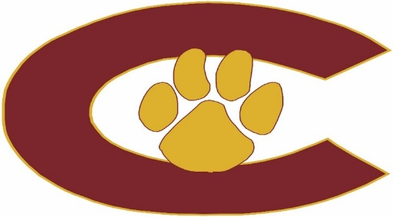

2025-26 BOYS GOLF

DATE OPPONENT SITE HOST
9/4 Seminole, St Pete Countryside CC Countryside
9/11 Clearwater, Lakewood Clearwater (?) Clearwater
TBD Largo, PHU Largo (?) Largo
9/25 Hollins, Osceola Countryside CC Countryside
9/29 Boca Ciega, Pinellas Park ? Pinellas Park
TBD PCAC tournament TBD

10/27-29 District Tournament TBD TBD
11/3-5 Regional Tournament TBD TBD
11/18-19 State Tournament TBD

TBD Banquet

Head Coach: Cory Raynor – Raynorc@pcsb.org
Principal: Taylor Henderson – hendersont@pcsb.org
Athletic Director: Erin Overall – overalle@pcsb.org
Athletic Coordinator: Tony Klemmer – klemmera@pcsb.org
Athletic Trainer: Tillery Greco – tillery.greco@baycare.org
Assistant Principals: Brad Bernstein and Robert Murphy

Last update: 7/16/2025

